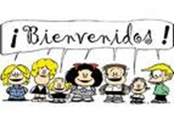

**Seňora Gittler – Room 107 World Language- Spanish Grades 6/7/8**

**Email: mgittler@jacksonsd.org**

***Course Materials:***

Chromebook daily·

· Required class materials: Notebook, folder & pen or pencil.

· Suggested class materials: Spanish/English pocket dictionary

**Grading Policy:**

30% Participation

20% Conversation

20% Exams

20% Homework

10% Projects **Total=100%**