6th Grade Computer Literacy
Ms. Salemi
Room 129
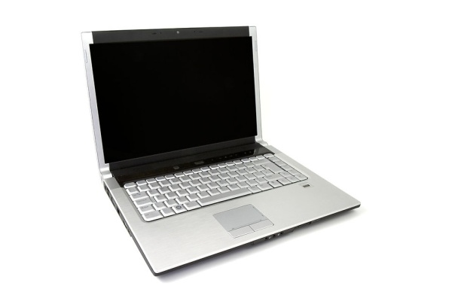
Dear Students and Families,
Welcome to another wonderful school year at McAuliffe! During this course, your child will explore fundamental technology programs and applications including word processing, spreadsheets, typing, hardware/software, coding fundamentals, and much more using computer software and Google Apps for Education.

This course will take place during marking period 1. In an effort to save paper, the class work will be located in our Google Classroom. More information regarding Google Classroom is forthcoming. All students and parents will have access to the online Google Classroom which can be accessed by clicking on direct links located on my teacher page. Check my class website frequently to stay updated with monthly units of study.

Course Description: 6th grade students will have an introduction to computer and informational literacy. Students will demonstrate skills, and use the tools necessary for computer applications. They will also understand the nature and impact of technology in their lives.

Materials Needed for Class: pencil/pen and a positive attitude
Always Appreciated Classroom Item: Tissues
School Website: www.jacksonsd.org
My class page: http://www.jacksonsd.org/Domain/74
Email: vmsalemi@jacksonsd.org

Thank you for your support!

Yours in Education,

Ms. Salemi

