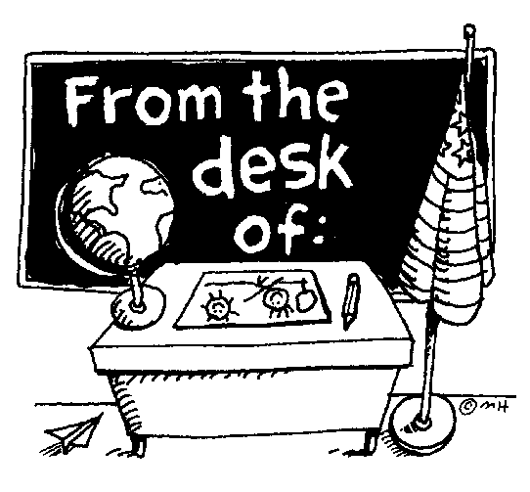
BIOLOGY

General Classroom Guidelines

Classroom requirements: 3-ring binder with paper
Pencils and pens (blue or black) J. Hudacko
Colored pencils Room 512

Students will be required to read, complete vocabulary and take notes for chapters being studied.

Be on time & prepared for class each day. Unprepared will result in lost participation points.

THERE WILL BE A FINAL EXAM.

Lab exercises are an important part of this course & students are expected to participate in each or do an alternate assignment if absent.

Projects are assigned periodically and require additional time outside of class.
All work should show effort and be in the student’s own words.

NO CREDIT will be given to plagiarized work.

All assignments: labs, homework, projects and classwork are due on their specific due dates.

It is the STUDENT’S RESPONSIBILITY to get all work to be made up if absent. Check the class pages for assignments so you don’t fall behind.

- LATE ASSIGNMENTS WILL NOT BE ACCEPTED!

- Cheating or Copying others work will NOT be tolerated and will result in a ZERO for that assignment.

If you are absent all work and/or tests MUST be made up within 5 days.
Tests must be made up after school so you do not miss instructional time.
Do not plan on taking the late bus home you may need more time to complete the exam.

Grading:
Assessment 55%
Participation 25%
Homework/classwork 20%

DO NOT expect to be given your grades. Students must do their own work and EARN their grade.

There is 0 tolerance for:

The Use of CELL PHONES, IPODS or any other electrical device during
class. The device will be confiscated and brought to the Vice Principal for
parent pick up.

Any type of disrespectful behavior
Students MUST treat everyone in the classroom with respect at all times.

Unacceptable behavior will result in immediate disciplinary action. (See
planner for discipline)

Detach Sign and Return to teacher Detach
----------------------------------------------------------------------------------------------------------------------------------------

BIOLOGY
“I have read the above classroom guidelines and understand their content.”

Student’s Name PRINTED __________________________________
Date ____________

Student’s Signature _______________________________________

Parent/Guardian’s Signature ________________________________

