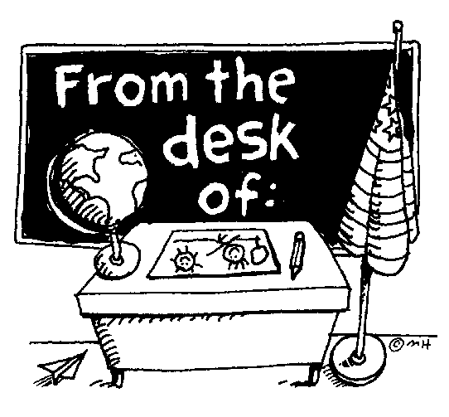
HONORS BIOLOGY Jackson Memorial H.S

This document outlines most of the rules, requirements & expectations for students in my
classes. PLEASE keep this in a safe place for reference.
Classroom requirements: 3-ring binder with paper
Folder with paper fasteners (for labs)
Pencils and pens (blue or black) J. Hudacko
Colored pencils and Highlighter Room 512
White out tape
Computer access with printer

GRADES: Marking period grades will be based on chapter tests, quizzes, labs, homework assignments,
class activities, worksheets, projects, written assignments and class participation. I will give advanced
noticed for all unit tests. If you have any questions regarding a grade, please see me after class to
schedule an after school appointment. I will not discuss any grades while other students are present.

Your marking period average will be calculated as follows:
60% = Assessment
25% = Participation
15% = Homework

- NO test corrections or extra credit assignments are given.

TEXTBOOK: To access the online textbook at home go to my class page and click on the link under
resources and using the following login information:
username = jbiology22 password = w7s8p

Textbooks will be available for use during your class period.

HOMEWORK: You will receive reading and written homework which includes outlining, vocabulary and
section review questions from the textbook. YOU MUST READ THE TEXTBOOK!!!
All written assignment MUST be neat & legible.
ALL HOMEWORK IS POSTED ON MY CLASS PAGE EVERYDAY and with the online textbook there is no
reason NOT to complete any book work.

LATENESS: ALL assignments, projects, lab write ups, etc. are to be submitted ON TIME at the beginning of the class period they are due. NO LATE ASSIGNMENTS WILL BE ACCEPTED

ABSENCES: Any student who is absent is expected to make up ALL work that was missed. Absences are
not an excuse from tests, homework or assignments. It is your responsibility to retrieve all notes and
assignments and hand them in. I WILL NOT chase after you for assignments. If a student is absent the
day of a test or quiz, they must see me to schedule an after school make-up date. All tests & quizzes
MUST be made up within 5 days of the original test date.

GENESIS: Grades are updated weekly.

***PARENTS: I strongly recommend checking genesis regularly to see how your child is
performing.

OTHER RULES & PROCEDURES:
- NO FOOD OR DRINK in the lab at any time.
- You must be on time to class that means in your seat when the bell rings. If you are late you will receive a detention.
- Keep the classroom and desks CLEAN (Writing on desks = Detention)
- When someone is speaking, show some respect and listen.
- Do not call out. PLEASE raise your hand.

ZERO (0) TOLERANCE:
- Cheating = an automatic ZERO (0) along with notification sent to your guidance counselor as well as parents/guardian.
- Copying assignments = both assignments confiscated & NO credit for either.
- Cell Phones, IPods or any other electronic devices during class will be confiscated and brought to the Vice Principals office for parent pick up.
- Disrespectful behavior towards the teacher or anyone in the classroom will result in a disciplinary referral.

You must complete your own work with effort, and EARN your grade.

Honors Course = Honors Quality Work (NO exceptions)

Detach Sign and Return to teacher Detach
----------------------------------------------------------------------------------------------------------------------------------------

HONORS BIOLOGY
“I have read the above classroom guidelines and understand their content.”

Student’s Name PRINTED ______________________ Date ____________

Student’s Signature ______________________________________

Parent/Guardian’s Signature ________________________________

