**Read It To Eat It Program**

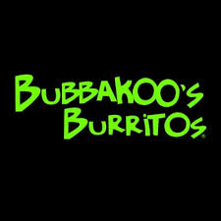

Dear Switlik Families,

In our continued effort to promote literacy and a love of reading, we have continued to partner with Bubbakoo’s for their "Read It to Eat It" program.

How it works:

1. "Book List Cards" will be placed in your mailboxes this week.
2. Students read and record 5 books during the month. These can be at home or school!
3. Return the filled in card to your child’s teacher.
4. The classroom teacher will sign the bottom and staple the "Free Student Meal Card" onto the "Book List Card" and give it back to your child.
5. Students take BOTH cards to Bubbakoo’s for a free student meal!

**Enjoy your books and free Bubbakoo’s!**