**EnVision Math Login Instructions for Students:**

New this school year, students will use their district Google account credentials to log into Pearson EnVision Math. You will no longer use a username or password to access your Math resources and class assignments.

Please find our login instructions below:

1. Log into your district Google account (or Gmail)
   1. Your email is **studentID**@jacksonsd.org
   2. If this is your first time logging into Gmail, your password is welcome#jsd.
2. Open a new tab and go to your school website (e.g. holman.jacksonsd.org)
3. At the top of the page, go to “FOR PARENTS & STUDENTS”
4. Click on “Envision Math Login”
5. You will be taken to the Pearson envision website and will be automatically signed in.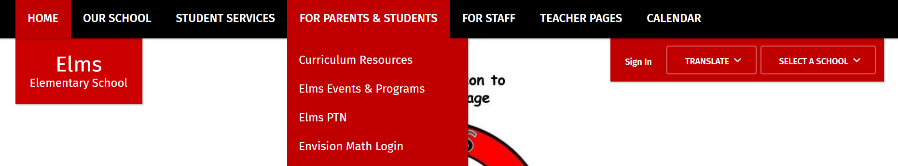

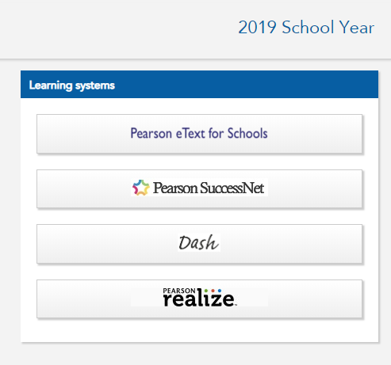

1. Click Pearson Realize on the right side and you’re ready to get your math on!

