NJ4S Compass Parent Session
Navigating the Digital World

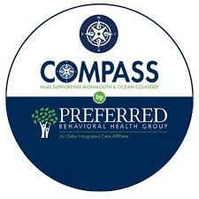

​

​Wednesday, October 8th
6:30 - 7:30 PM
Switlik APR

Dear ​Families,
You're invited to a special presentation on Navigating the Digital World, presented by Preferred Behavioral Health Group and NJ4SCompass.
In today's connected world, raising kids presents new challenges. This presentation will provide you with the tools and insights you need to help your children stay safe, responsible, and healthy online.
The program will cover cybersafety, cyberbullying, and managing your child's digital footprint. The presentation aims to educate participants on online safety, the impacts of cyberbullying, and effective online identity management.
Please note: this evening is intended for parents only.
Join us for an evening of learning and open discussion. Our experts will be available to answer your questions and share practical strategies. Let's work together to create a positive and secure digital environment for our kids.
Please RSVP to this event​ ​HERE.
We are looking forward to seeing you at this parent session.
Sincerely,
Mr. Michael Saulnier, Principal

