**Page #1, Archery Range Handout – © Mathew Simon, Pack-754**

Archery Range Rules

1. Know and obey all range commands.

1. Keep your arrows in your quiver until you are told to shoot. Always wear your arm guard, finger tab and eye protection.

1. Only use the arrows the instructor gave you.

1. Always keep your arrows pointed down or toward the target. Shoot only at your target.

1. If you drop an arrow, leave it on the ground until you are told to get your arrows from the target.

1. Always walk at the archery range. (No running inside the Range.)

Archery Range Whistle Commands

|  |  |  |
| --- | --- | --- |
| **Whistle signal** | **Verbal Command** | **Meaning** |
| One Blast | Archers to the shooting line | Pick up bow and move into position on the shooting line (Keep arrows in quiver) |
| Two Blasts | Begin shooting | Archers may now take the arrows out of the quivers and begin shooting |
| Three Blasts | Walk forward and retrieve your arrows | Archers have completed all shooting; all archers have set their bows on the rack and are behind the waiting line. They may now go forward and prepare to pull their arrows from the target. |
| Four or more Blasts | Cease Fire! Or  STOP, STOP, STOP! | Immediately let down and put arrows back in your quiver. There is an emergency on the range |

Archery Range Procedures

* Wait behind the waiting line until you hear 2 whistle blasts or “Archers to the shooting line”. Pick up your bow and straddle the shooting line.

* Keep your arrows in your quiver until you hear 1 whistle or “Begin shooting”.

* After you have shot all your arrows, step back from the shooting line, set your bow on the rack and wait behind the waiting line.

* After everyone is done shooting and behind the waiting line, the instructor will blow the whistle 3 times or give the command “Walk forward and retrieve arrows”. Walk to the target line and wait for instructions on pulling your arrows from the target.

Procedures for Retrieving Arrows

* One archer at a time from each target may step forward from the **target line** to pull their arrows.

* Stand to the side of the target and make sure no one is standing behind your arrows.

* Pull your arrows out one at a time and put them in your quiver.
* After you have pulled all your arrows, return to the waiting line.

**Page #1, Archery Range Handout – © Mathew Simon, Pack-754**

Archery Target and Scoring

|  |  |
| --- | --- |
| **Color** | **Score** |
| Gold | 10 |
| Gold | 9 |
| Red | 8 |
| Red | 7 |
| Blue | 6 |
| Blue | 5 |
| Black | 4 |
| Black | 3 |
| White | 2 |
| White | 1 |

The common archery target has 10 rings in it. The score is calculated as follows.

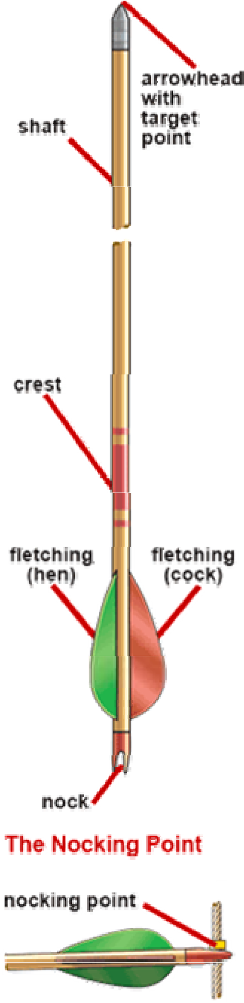

Common bows and Arrows

**Longbow (Stick bow)**

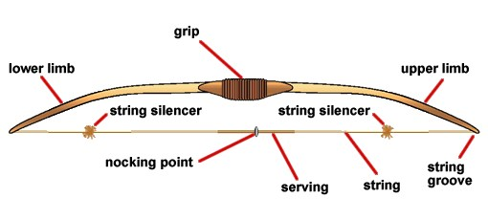

The "traditional" bow, which has straight limbs that form an arc when strung.

Used by those interested in traditional shooting with little additional equipment.

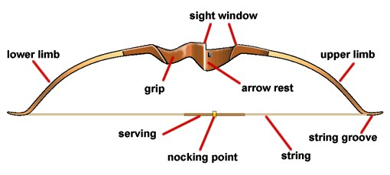**Recurve Bow**

Much like the longbow, but the limbs curve back away from the belly of the bow, which can provide more power in a shorter bow than the longbow.