Neurological Disorders Project  Neurological disorders are diseases of the central and peripheral nervous system. In other words, the brain, spinal cord, cranial nerves, peripheral nerves, nerve roots, autonomic nervous system, neuromuscular junction, and muscles. These disorders include epilepsy, Alzheimer disease, Parkinson's disease and many others.  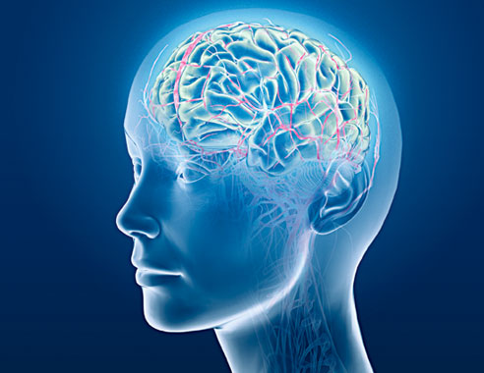  Mental disorders, on the other hand, are "psychiatric illnesses" or diseases which appear primarily as abnormalities of thought, feeling or behaviour, producing either distress or impairment of function.  Hundreds of million of people worldwide are affected by neurological disorders: For example, 50 million people have epilepsy; 62 million are affected by cerebrovascular disease; 326 million people suffer from migraine; 24 million are affected by Alzheimer disease and other dementias globally.  TASK  You will research a disorder or disease of the nervous system and present your findings in the form of a Powerpoint Presentation.  Include the following information in this order:  - Description of the disorder - focus on Anatomy and Physiology of the brain and nervous system.  - Images relating to the disorder - these could be MRI's of the brain or even photos of people  - Symptoms, describe what life is like for a person with the disorder  - How does a person get the disorder - it might be genetic, the result of an injury, or possibly the factors are unknown.  - Treatment options - can it be cured or can the symptoms be managed?  - Additional Information - add a few extra things related to the disorder, this could be slides of famous people who have the disorder, organizations about the disorder, trivia, medical history. You can also link to a short video from a news site.  * Be aware of your audience (the class) and avoid overly technical medical information - avoid copy pasting from sites. You want your presentation to be understood by the average person. | You may choose any of the following disorders. If one is not on the list, check with your teacher to see if it is appropropriate.  - Alzheimer's Disease  - Asperger's Syndrome  - Attention Deficit Disorder  - Autism  - Bipolar Disorder  - Dissociative Disorder  - Depression  - Cerebral palsy  - Dyslexia  - Epilepsy  - Fetal Alcohol Syndrome  - Huntington's Disease  - Migraines  - Multiple Sclerosis  - Narcolepsy  - Parkinson's Disease  - Huntington's Disease  - Rett Syndrome  - Panic Disorder  - Obsessive Compulsive  - Schizophrenia  - Spina Bifida  - Stroke  - Tourette Syndrome  Website Resources  Once you have chosen the disorder you want to study, use google to research it. The following sites may also be helpful  Neuroscience for Kids  Health Insite (Brain Diseases)  Brainweb (Dana Foundation)  Washington U. Disorders PageMentalHealth.com

SCORING
 | Excellent (4) | Good (3) | Fair (2) | Needs Work (1) | Not Evident
Information: Anatomy & Physiology
Abundance of facts that relate to the disorder, includes specific information about the brain, or cells are biological processes
Information: Symptoms, list and descriptions of the most common
Information: Developing the Disorder. Is it genetic, environmental?
Information: Treatment of the Disorder. What medications are used, how does a person live with the disorder?
Additional Information: History, Famous people, Trivia, Possibly a video included
Information: Audience (Target audience is addressed)
Organization: Follows a logical order, transitions are smooth
Creativity: Use of images, slide transitions, bulleted lists, etc
 | TOTAL (out of 30)

